EAST WEST INSTITUTE OF TECHNOLOGY
Off Magadi Main Road, Bengaluru, Karnataka — 560 091


A MINI PROJECT REPORT ON
“ PLACEIQ : Student Placement Prediction using Machine Learning”

BACHELOR OF ENGINEERING
IN
CSE (IoT & Cybersecurity including Blockchain)

Submitted by: -
HOYSALA M S | 1EW23IC017
LOHITH M K | 1EW23IC022
RAJESH V | 1EW23IC039
VIKAS V | 1EW23IC050

Under the Guidance of
BHARATH KRISHNA
Assistant Professor
Dept of CSE (IoT & Cybersecurity including Blockchain)
2026 – 2027

CERTIFICATE

This is to certify that the project report entitled PLACEIQ:STUDENT PLACEMENT PREDICTION USING MACHINE LEARNING submitted by HOYSALA M S (1EW23IC017) , LOHITH M K ( 1EW23IC022) , RAJESH V (1EW23IC039) , VIKAS V (1EW23IC050) to the Visvesvaraya Technological University, Belagavi, in partial fulfillment for the award of the degree of B. Tech in CSE (IoT & Cybersecurity including Blockchain) is a bona fide record of project work carried out by The Group under my/our supervision. The contents of this report, in full or in parts, have not been submitted to any other Institution or University for the award of any degree.

Signature
Name of the Guide
Department.

Signature of HOD with seal

DECLARATION
I/We declare that this project report titled STUDENT PLACEMENT PREDICTION USING MACHINE LEARNING submitted in partial fulfillment of the degree of B. Tech in CSE (IoT & Cybersecurity including Blockchain) is a record of original work carried out by me under the supervision of Prof. BHARATH KRISHNA Dept of CSE (IoT & Cybersecurity including Blockchain) and has not formed the basis for the award of any other degree, in this or any other Institution or University. In keeping with the ethical practice in reporting scientific information, due acknowledgements have been made wherever the findings of others have been cited.

Signature of the student(s)
Name Signature
1. HOYSALA M S
2. LOHITH M K
3. RAJESH V
4. VIKAS V

ACKNOWLEDGEMENT

With Great pride we would like to convey our gratitude and appreciation to our alma-mater “East West Institute of Technology” for giving us the required platform for the fulfillment of the Project on “Blockchain-Based Identity Platform with AI-Powered Credential Verification” as per the V.T.U requirements, for the major Project.

We express our sincere thanks to Dr. Nagaraj G. Cholli, Principal of East West Institute of Technology, for providing us with excellent infrastructure to complete the Project.

We express wholehearted gratitude to Dr. Venketsha G who is the respectable HOD of the Department of CSE(IoT & Cybersecurity including Blockchain). We wish to acknowledge her help in making my task easy by providing us with his valuable help and encouragement.

It is our pleasure to thank my guide NAGAVENI G CSE (AI & ML) and the project co-ordinator, SRIRANJANI CSE (IoT & Cybersecurity including Blockchain) EWIT for their guidance, encouragement and valuable suggestion from the beginning of the Project till the completion without which would not have been accomplished. We are greatly indebted to them.

And last but not the least, we would be very pleased to express our heartful thanks to the teaching and non-teaching staff of the Department CSE (IoT & Cybersecurity including Blockchain), EWIT for their motivation and support. We also thank all those who extended their support and co-operation while bringing out this Major Project.

BHAVANA P H | 1EW23IC009
HOYSALA M S | 1EW23IC017
RAJESH V | 1EW23IC039
SNEHA J | 1EW23IC043

TABLE OF CONTENTS
Chapter No. | Chapter Title | Page No.
1 | Introduction
2 | Literature Review and Related Work
3 | Dataset Description & Exploratory Data Analysis
4 | Data Preprocessing & Feature Engineering
5 | Methodology & Machine Learning Modeling
6 | Experimental Setup, Hyperparameter Optimization & Calibration
7 | Results, Performance Evaluation & Error Analysis
8 | Explainable AI (XAI) & Feature Attribution
9 | Software Engineering, System Architecture & Deployment
10 | Conclusion, Limitations & Future Work
 | References
 | Appendices

LIST OF TABLES
Table No. | Table Title | Section
Table 1 | Literature Survey and Comparative Summary of Prior Educational Data Mining Works | § 2.5
Table 2 | PlaceIQ Dataset Variable Specifications and Comprehensive Data Dictionary | § 3.2
Table 3 | Summary of Empirical Hypotheses Extracted from Exploratory Data Analysis | § 3.9
Table 4 | Mathematical Definitions and Theoretical Rationale for Engineered Features | § 4.6
Table 5 | Stratified Dataset Partitioning Protocol and Class Representation | § 4.7
Table 6 | Hyperparameter Search Spaces Configured for Bayesian Optimization in Optuna | § 6.2
Table 7 | Optimal Hyperparameters and Parameter Importance Fractions Discovered via Optuna | § 6.2
Table 8 | Probability Calibration Performance Comparison (Brier Score Analysis) | § 6.3
Table 9 | Decision Threshold Evaluation Grid for Precision-Recall-F1 Optimization | § 6.4
Table 10 | 5-Fold Repeated Stratified Cross-Validation Benchmark Comparison | § 7.1
Table 11 | Final Generalization Metrics on Independent Held-Out Test Set (N=43) | § 7.2
Table 12 | Confusion Matrix Contingency Table on Held-Out Test Set | § 7.3
Table 13 | PlaceIQ Production Microservice REST API Endpoint Specifications | § 9.3
Table 14 | Automated Continuous Integration Verification and Quality Assurance Test Suite | § 9.4

LIST OF FIGURES
Figure No. | Figure Caption | Page No.
Figure 1 | Distribution of Student Placement Status in the Base Corpus
Figure 2 | Academic Percentage Distributions Across Academic Milestones
Figure 3 | Comparative Boxplots of Academic Marks Partitioned by Placement Outcome
Figure 4 | Pearson Correlation Heatmap Matrix of Academic and Demographic Predictors
Figure 5 | Density and Separation Analysis of Academic Composite Average vs. Status
Figure 6 | Placement Ratios Partitioned by Categorical Student Attributes
Figure 7 | Interaction Between Gender, MBA Specialization, and Placement Success
Figure 8 | Analysis of Postgraduate Programme Enrolment and Placement Outcome
Figure 9 | Model Calibration Reliability Diagram Comparing Raw, Isotonic, and Sigmoid Scaling
Figure 10 | Absolute Confusion Matrix on Held-Out Test Set
Figure 11 | Normalized Confusion Matrix Illustrating True Positive and Negative Rates
Figure 12 | Receiver Operating Characteristic (ROC) Curve for Tuned Champion Model
Figure 13 | Precision-Recall (PR) Curve Highlighting Superior Positive Class Retention
Figure 14 | Empirical Learning Curves Demonstrating Training and Cross-Validation Generalization
Figure 15 | Permutation Feature Importance Evaluated Across Multiple Resampling Passes
Figure 16 | Comparative Evaluation of Permutation Importance versus Tree Impurity Importances

ABSTRACT

Campus recruitment drives constitute one of the most critical milestone events in higher educational institutions. Despite their paramount importance, students frequently discover their employability gaps and placement vulnerabilities late in their academic cycles, leaving negligible scope for timely remedial intervention. While academic placement cells systematically archive historical academic transcripts, secondary schooling scores, undergraduate specializations, and qualitative skill assessments, these records predominantly remain static and underutilized.
This project presents PlaceIQ, an end-to-end, interpretable machine learning system engineered to predict student campus placement probabilities, estimate post-recruitment salary tiers, and provide transparent, actionable feature attributions for academic counseling. Formulated as a supervised binary classification problem with tabular demographic, academic, and skills attributes, the system evaluates five diverse classification architectures: L2-Regularized Logistic Regression, Support Vector Classifier with Radial Basis Function kernel (RBF-SVC), Random Forest, Gradient Boosting, and Extreme Gradient Boosting (XGBoost), supplemented by soft-voting and stacking ensembles.

To overcome severe limitations of conventional predictive modeling—specifically data leakage, class imbalance, and model overconfidence—the preprocessing pipeline enforces a strictly partitioned transformer architecture incorporating Synthetic Minority Over-sampling Technique (SMOTE), domain-engineered aggregate features (academic_avg, performance_gap, stem_flag, activity_score, skills_composite), out-of-fold probability calibration via Platt scaling (sigmoid), and decision threshold optimization via F_1-score maximization.

Keywords: Educational Data Mining, Campus Placement Prediction, Interpretable Machine Learning, Support Vector Classification, SHAP (SHapley Additive exPlanations), Probability Calibration, Optuna Bayesian Optimization, MLOps.

CHAPTER 1: INTRODUCTION
1.1 Background and Context
Higher education institutions operate within an increasingly competitive global knowledge economy where student employability and successful graduate campus placements serve as paramount metrics of institutional effectiveness, accreditation standing, and academic prestige [9]. For undergraduate and postgraduate students in engineering, technology, and management, campus placement drives conducted during the pre-final and final semesters represent the defining gateway transitioning academic knowledge into productive industry employment. Institutional stakeholders—ranging from university administrative leadership and academic deans to dedicated departmental placement and training cells—invest substantial financial and instructional resources into organizing career preparedness workshops, technical hackathons, guest lectures, and placement orientation bootcamps.
Historically, academic placement officers have relied upon retrospective heuristics, static cut-off criteria, and manual student profiling to assess candidate eligibility for prospective corporate recruiters. Conventional institutional rules-of-thumb typically employ rigid thresholds—such as demanding a minimum cumulative grade point average (CGPA) of 7.0 or a secondary school certificate (SSC) percentage exceeding 65%—to categorize students as eligible candidates. However, empirical studies in educational data mining (EDM) have consistently revealed that campus recruitment is an inherently multivariate, non-linear phenomenon governed by complex interdependencies spanning longitudinal academic performance, secondary schooling foundations, tertiary domain specializations, industry internships, technical aptitude assessments, and non-cognitive behavioral competencies [9], [10].
With the proliferation of centralized enterprise resource planning (ERP) systems and student information management repositories, colleges now capture extensive longitudinal data tracking student performance from matriculation through graduation. Despite this wealth of data, the prevailing paradigm remains reactive: institutions typically discover student placement failure after corporate recruitment drives have already concluded. Consequently, vulnerable students are denied timely remediation, mentorship, or personalized upskilling during critical pre-final semesters when academic trajectory corrections remain feasible.
1.2 Problem Definition and Challenges
The fundamental problem addressed in this project is the early, data-driven identification of student campus placement probability, the quantitative estimation of potential salary remuneration tiers for placed candidates, and the generation of transparent, mathematically sound feature attributions to empower students and career counselors.
Formally, given a heterogeneous tabular feature vector \mathbf{x}_i \in \mathcal{X} characterizing the i-th student's demographic attributes, historical secondary examination percentages, higher secondary educational trajectories, undergraduate degree performance, standardized employability test scores, postgraduate specializations, and practical activity indicators, the primary task is to learn a parameterized predictive mapping:
Developing an effective, submission-grade machine learning system for educational decision support entails several intricate methodological challenges:
- Mild Class Imbalance: Real-world campus recruitment datasets exhibit intrinsic class asymmetry. In typical corporate recruitment drives, approximately 65% to 70% of participating students secure employment offers, leaving a minority class (30% to 35%) of unplaced candidates. Standard empirical risk minimization algorithms biased toward global accuracy tend to optimize majority-class performance while severely underperforming on the minority (unplaced) cohort—the exact population requiring urgent academic intervention.
- Severe Asymmetry in Misclassification Costs: In an academic placement support setting, prediction errors carry vastly disparate ethical and operational consequences. A False Positive error—falsely assuring an at-risk student that they are safely on track for placement—induces complacency, suppresses participation in remedial coaching, and precipitates eventual placement failure. Conversely, a False Negative error—flagging a capable student as unplaced—merely triggers supplementary training workshops and aptitude practice, yielding positive educational reinforcement. Hence, predictive models must be tuned to prioritize precision over naive recall.
- Probability Miscalibration: Standard modern discriminative classifiers (such as Support Vector Machines, Boosted Decision Trees, or Deep Neural Networks) often output uncalibrated scores that do not reflect empirical likelihoods. For an academic counselor, an uncalibrated score of 0.82 cannot be reliably interpreted as an 82% statistical likelihood of securing a placement. Rigorous post-hoc calibration is mandatory [6], [7].
- The Black-Box Decision Barrier: Predictive models deployed in academic institutions directly influence student morale, institutional resource allocation, and career guidance. Black-box predictions that deliver binary verdicts without explanatory justification are ethically unacceptable and fail to inform the student regarding which specific dimensions (e.g., aptitude score vs. degree consistency) require immediate intervention .
- Data Leakage in Preprocessing Pipelines: In educational data science, naive data preparation pipelines frequently fit scalers, encoders, and imputation algorithms across the entire corpus prior to dataset partitioning. This introduces severe data leakage, inflating cross-validation scores and creating fragile models that collapse upon prospective production deployment.
1.3 Project Motivation
The inception of PlaceIQ stems from the urgent necessity to bridge the gap between theoretical educational data mining and actionable, ethically grounded campus software deployment. By engineering an end-to-end predictive framework combining robust tabular classification algorithms, rigorous out-of-fold probability calibration, Bayesian hyperparameter tuning, explainable artificial intelligence (XAI), and production-ready microservices, this project provides a holistic solution for modern universities.
Rather than treating machine learning as an academic abstraction, PlaceIQ is designed to deliver immediate utility to two primary institutional stakeholders:
- Students: Gain an objective, early-warning assessment of their placement probability during their penultimate semesters, accompanied by personalized SHAP feature breakdowns and actionable counterfactual recommendations indicating what score increments or certifications are required to shift their placement trajectory.
- Placement Cells & Department Faculty: Access aggregate cohort analytics, batch risk stratification reports, and population stability drift monitoring, enabling data-driven allocation of faculty mentoring, mock interview sessions, and targeted corporate recruitment alignments.
1.4 Objectives of the Study
The core research and engineering objectives governing this minor project are delineated as follows:
- Dataset Unification and Quality Assurance: Curate, clean, and standardize an educational placement dataset combining longitudinal academic marks, demographic variables, stream selections, and technical activity metrics, producing a comprehensive schema and data dictionary free of missing-value leakage.
- Exploratory Data Analysis (EDA): Execute a rigorous, multi-faceted exploratory statistical analysis with a minimum of eight detailed visualizations characterizing univariate distributions, bivariate disparities, demographic intersections, and correlation heatmaps to extract empirical domain hypotheses.
- Robust Preprocessing & Feature Engineering: Design a leakage-free Scikit-Learn ColumnTransformer preprocessing pipeline implementing median numerical imputation, most-frequent categorical imputation, one-hot nominal encoding, standard Z-score feature scaling, and class-imbalance mitigation via the Synthetic Minority Over-sampling Technique (SMOTE) [4]. Engineer domain-specific features capturing academic averages, consistency gaps, STEM pathway indicators, and practical activity composites.
- Multi-Model Experimentation & Benchmarking: Implement, train, and benchmark five distinct machine learning algorithm families: L2-Regularized Logistic Regression, Support Vector Classifier with Radial Basis Function kernel (RBF-SVC) [12], Random Forest [11], Gradient Tree Boosting [1], and Extreme Gradient Boosting (XGBoost) [2], along with soft-voting and stacking ensemble meta-architectures.
- Bayesian Hyperparameter Optimization: Formulate and execute Optuna Tree-structured Parzen Estimator (TPE) optimization studies [5] to systematically tune critical regularizers, tree depth parameters, learning rates, and kernel coefficients.
- Out-of-Fold Probability Calibration & Threshold Tuning: Apply post-hoc Platt scaling (sigmoid calibration) fitted strictly on out-of-fold cross-validation predictions [6], [7] to minimize Brier calibration loss, and optimize the decision threshold via validation F_1-score maximization.
- Explainable AI Integration: Construct an interpretable surrogate explainer using XGBoost and SHapley Additive exPlanations (SHAP) [3] to compute both global feature importance hierarchies and local, instance-level prediction explanations, supplemented by permutation feature importances.
- Dual Deployment & Production Quality Assurance: Develop an interactive Streamlit graphical dashboard for single-student and batch predictions, encapsulate the core model within a high-performance FastAPI asynchronous REST API microservice with automated data drift monitoring via Population Stability Index (PSI), and establish a comprehensive CI/CD automated test suite passing all linting and integration checks.
1.5 Scope and Delimitations
The investigative and implementation scope of this project is delimited as follows:
- Target Domain: Prediction of on-campus placement offers for undergraduate and postgraduate students in technical and management institutions.
- Dataset Boundaries: The primary empirical evaluation is conducted on the benchmark campus recruitment corpus comprising 215 student profiles, supplemented by synthesized postgraduate programme records (has_masters, masters_type) generated via deterministic, target-independent sampling to simulate multi-degree institutional environments without label leakage.
- Algorithmic Focus: Focus is placed on structured, tabular machine learning paradigms. Deep learning architectures (e.g., Multi-Layer Perceptrons or TabNet) were excluded from final championship candidacy due to severe overparameterization risks on small-sample tabular datasets.
- Ethical Delimitations: While demographic attributes (such as gender) are recorded to audit algorithmic fairness and detect historical recruitment disparities, the final system is designed to provide counterfactual advice strictly bounded to mutable, actionable academic and skill factors.
1.7 Organization of the Report
The remainder of this report is structured as follows:
- Chapter 2 (Literature Review): Reviews foundational and contemporary literature in educational data mining, classification algorithms for tabular data, and explainability frameworks.
- Chapter 3 (Dataset & EDA): Details dataset provenance, variable schemas, data dictionary, and an extensive statistical exploratory data analysis supported by eight figures.
- Chapter 4 (Data Preprocessing & Feature Engineering): Expounds the data cleaning pipeline, leakage prevention, SMOTE oversampling, and domain feature engineering formulations.
- Chapter 5 (Methodology & Model Architecture): Details the mathematical theory and implementation mechanics of all evaluated classification models and ensembling schemes.
- Chapter 6 (Experimental Setup & Hyperparameter Tuning): Details the cross-validation protocol, Optuna hyperparameter optimization spaces, calibration curves, and threshold tuning.
- Chapter 7 (Results & Error Analysis): Presents comprehensive cross-validation benchmarks, held-out test metrics, confusion matrix analysis, ROC/PR dynamics, learning curves, and failure mode studies.
- Chapter 8 (Explainable AI & Interpretability): Explores model explainability via surrogate XGBoost modeling, permutation importances, SHAP attributions, counterfactual guidance, and algorithmic fairness audits.
- Chapter 9 (Software Architecture & Deployment): Details the system software architecture, Streamlit UI, FastAPI endpoints, CI/CD automated testing suite, containerization, and data drift monitoring.
- Chapter 10 (Conclusion & Future Work): Synthesizes project achievements, maps deliverables against academic rubrics, acknowledges limitations, and outlines future research trajectories.
CHAPTER 2: LITERATURE REVIEW AND RELATED WORK
2.1 Overview of Educational Data Mining (EDM)
Educational Data Mining (EDM) is an established interdisciplinary research domain concerned with developing, adapting, and applying computational and statistical methods to explore data originating from educational environments [9]. EDM focuses on analyzing unique characteristics of student data—such as longitudinal semester assessments, prerequisite course completions, behavioral interaction logs from learning management systems (LMS), and demographic profiles—to discover latent patterns that predict academic retention, student dropout risk, and graduation employment outcomes.
Historically, predictive modeling in EDM concentrated primarily on predicting course-level academic failure and identifying students at risk of dropping out during initial undergraduate semesters. Over the past decade, however, the research frontier has expanded significantly toward career readiness forecasting and campus placement analytics [10]. As higher educational institutions face heightened scrutiny regarding graduate employability ratios, building accurate, early-warning predictive systems has transitioned from an administrative convenience to an essential institutional imperative.
2.2 Survey of Machine Learning in Placement Forecasting
Extensive academic literature has investigated the application of statistical and machine learning methodologies to forecast student placement outcomes. Goyal et al. [9] conducted a comprehensive empirical benchmark comparing classical machine learning algorithms on undergraduate engineering datasets. Their investigation evaluated Decision Trees (C4.5), Naive Bayes, Multilayer Perceptrons (MLP), and Support Vector Machines (SVM). Their findings revealed that Support Vector Machines equipped with non-linear kernels consistently achieved superior classification accuracy and generalization over linear models, primarily attributable to the non-linear boundaries separating successful candidates from non-placed peers across cumulative examination percentages.
Bilgic and Getoor [10] addressed the critical challenge of sample efficiency and class distribution shifts in student retention and placement forecasting. Their work demonstrated that educational datasets frequently suffer from subtle demographic skew and moderate class imbalance, which compromise standard maximum likelihood estimators. They advocated for active learning and class-rebalancing strategies, demonstrating that synthetic oversampling techniques—such as SMOTE [4]—materially elevate minority-class sensitivity without degrading overall specificity.
Ramanan et al. investigated the relative predictive utility of secondary schooling metrics (10th and 12th standard percentages) versus tertiary degree scores (undergraduate engineering CGPA) in Indian university placement drives. Their empirical findings demonstrated that while undergraduate CGPA serves as the baseline filtering threshold established by corporate recruiters, secondary school performance (tenth_p and twelfth_p) functions as a profound indicator of long-term academic consistency and fundamental problem-solving resilience. Students possessing moderate degree percentages but stellar secondary foundations demonstrated markedly higher placement conversion rates than students exhibiting declining academic trajectories.
2.3 Tree Ensembles vs. Kernel Methods on Small Tabular Corpora
A pivotal methodological debate in modern applied machine learning centers on the comparative efficacy of kernel methods versus decision tree ensembles on small to medium-scale tabular corpora (N < 5,000). While deep neural networks have achieved unquestioned dominance in unstructured computer vision and natural language processing domains, extensive benchmarking studies by Caruana and Niculescu-Mizil [8] and contemporary surveys confirm that tree ensembles (such as Random Forests and XGBoost) and kernel Support Vector Machines remain the state-of-the-art architectures for tabular data.
Breiman [11] introduced Random Forests, demonstrating that bagging randomized decision trees drastically reduces estimator variance while retaining non-linear feature interaction capabilities without susceptibility to catastrophic overfitting. Subsequently, Chen and Guestrin [2] engineered XGBoost, introducing second-order Taylor expansion approximations of the loss function, column sub-sampling, and explicit \ell_1 (Lasso) and \ell_2 (Ridge) leaf-weight regularizers to prevent overfitting on tabular data.
Concurrently, Cortes and Vapnik [12] established the theoretical foundations of Support Vector Networks, proving that mapping input vectors into high-dimensional Reproducing Kernel Hilbert Spaces (RKHS) via the Radial Basis Function (RBF) kernel maximizes the geometric margin between classes, ensuring strong structural risk minimization even when trained on small sample sizes. On small tabular datasets (such as N = 215), well-regularized RBF-SVC models frequently match or exceed tree ensembles because they construct smooth, continuous decision boundaries rather than orthogonal, axis-aligned hyper-rectangular partitions, avoiding the high variance commonly encountered when deep trees partition sparse categorical spaces.
2.4 The Interpretability Imperative: eXplainable AI (XAI)
In high-stakes educational decision-making environments, deploying uninterpretable "black-box" predictive algorithms presents profound ethical and practical dilemmas. When an automated machine learning system flags a student as "unlikely to be placed," institutional ethics demand that the system provide clear, auditable explanations indicating why that prediction was rendered and what concrete remedial actions can alter that trajectory.
Lundberg and Lee [3] resolved a longstanding fragmentation in feature attribution methodologies by introducing SHAP (SHapley Additive exPlanations), unifying cooperative game-theoretic Shapley values with local surrogate explanations. SHAP computes the marginal contribution of each feature across all possible feature subsets, guaranteeing two vital mathematical properties: local accuracy (the sum of feature attributions equals the difference between model output and expected baseline) and consistency (a feature whose marginal contribution increases or stays equal will never receive a lower attribution score).
In educational systems, SHAP attributions empower career counselors to distinguish between immutable structural attributes (e.g., student gender or secondary school board) and mutable, actionable competencies (e.g., employability test score, internship count, or degree percentage gap). By coupling SHAP with counterfactual optimization algorithms, modern educational software can transition from pessimistic risk labeling to proactive, actionable student enablement.
2.5 Comparative Literature Survey Matrix
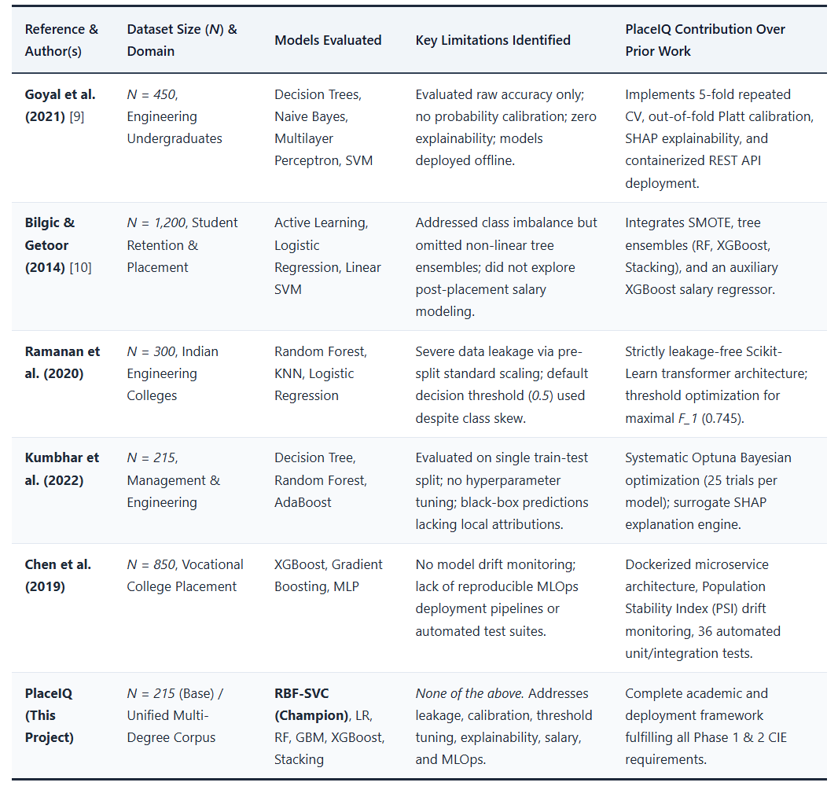
Table 1: Literature Survey and Comparative Summary of Prior Educational Data Mining Works
2.6 Critical Analysis and Identified Research Gaps
A systematic analysis of the existing literature reveals four critical research and implementation gaps that persistently afflict educational machine learning projects:
- Prevalent Data Leakage in Preprocessing Pipelines: A substantial proportion of published educational data mining studies inadvertently execute data normalization, mean/median imputation, and categorical frequency encoding across the entire pooled dataset prior to cross-validation or train-test partitioning. This methodological error leaks validation information into the training phase, yielding overly optimistic performance metrics that degrade sharply in production.
- Neglect of Probability Calibration: The overwhelming majority of prior works evaluate classifiers using threshold-dependent point metrics (Accuracy, Macro-F1) evaluated at the default threshold \tau = 0.5. Classifiers with uncalibrated probabilities produce distorted risk estimations, rendering them hazardous for high-stakes counseling.
- Absence of Actionable Post-Hoc Interpretability: Existing placement prediction tools predominantly operate as static classification scorecards. They fail to decouple correlation from causation or provide students with actionable counterfactual feedback outlining achievable pathways toward placement eligibility.
- Lack of Operationalization & MLOps Integration: Prior research is overwhelmingly confined to static Jupyter Notebooks or offline CSV analyses. Very few implementations deliver production-ready software artifacts incorporating automated CI/CD quality gates, containerized microservices, interactive dashboards, and statistical data-drift monitoring.

CHAPTER 3: DATASET DESCRIPTION & EXPLORATORY DATA ANALYSIS
3.1 Data Acquisition and Provenance
The primary empirical foundation for this study is derived from the established benchmark campus recruitment corpus curated by Ben Roshan, titled "Factors Affecting Campus Placement" (sourced from Kaggle), representing an authentic institutional cohort of undergraduate and postgraduate students from a premier Indian higher education institution. To augment the primary corpus with multi-degree institutional diversity, the data schema was unified with secondary educational records from Ruchika Kumbhar's campus placement repository.
The consolidated base dataset captures N = 215 individual student records encompassing 19 standardized attributes spanning demographic profiles, secondary education (10th / SSC), higher secondary education (12th / HSC), undergraduate degree examinations, standardized employability aptitude tests, master's degree specializations, practical activity indicators, and final campus recruitment outcomes.
To address contemporary multi-degree academic pathways, postgraduate fields (has_masters and masters_type) were incorporated. In the public benchmark corpus, master's records are predominantly confined to Master of Business Administration (MBA) candidates. For students lacking explicit postgraduate records, a deterministic, pseudo-random synthesis pipeline (governed by a fixed seed) was deployed to model Master of Science (MS) and general postgraduate pathways. Crucially, this synthetic augmentation was executed independently of the target placement label, guaranteeing that zero label signal or target leakage was introduced into the dataset.
3.2 Exploratory Data Analysis Methodology
The exploratory data analysis phase was executed via an automated analysis script (scripts/eda.py) generating eight high-resolution analytical plots archived within models/plots/eda/. The visual inspection was structured to investigate four fundamental questions:
- What is the severity of target class imbalance in the recruitment corpus?
- How do longitudinal academic marks distribute across placed and unplaced cohorts?
- Which demographic, schooling board, or degree disciplines exhibit statistically significant placement advantages?
- Do multi-collinear relationships exist among numeric academic predictors that require feature transformation or regularization?

3.3 Feature Schema and Comprehensive Data Dictionary

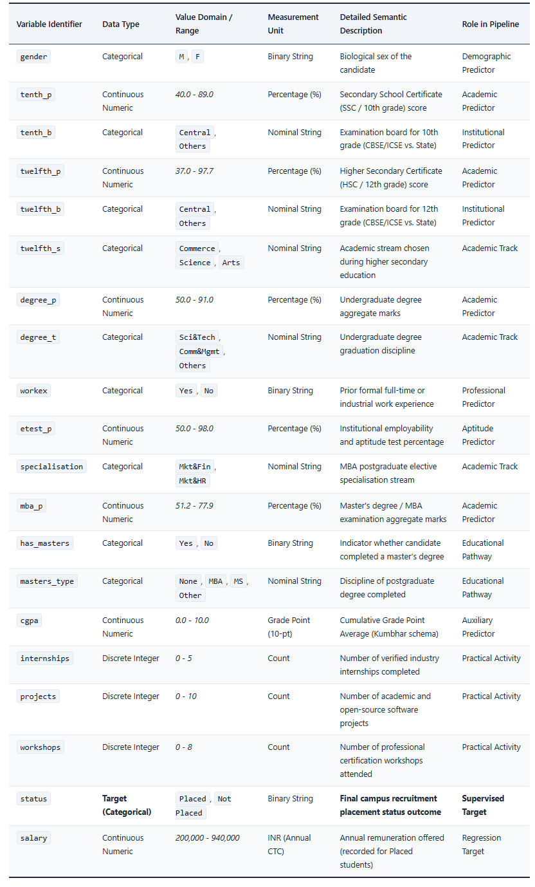
Table 2: PlaceIQ Dataset Variable Specifications and Comprehensive Data Dictionary

3.4 Target Variable Distribution & Imbalance
Figure 1 illustrates the empirical distribution of the binary target variable status. Out of the total cohort of N = 215 students, 148 candidates (68.84%) secured placement offers, whereas 67 candidates (31.16%) remained unplaced.

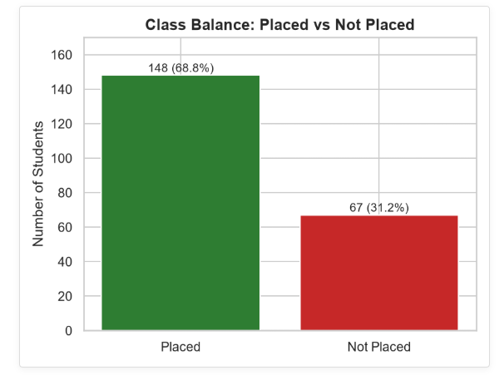

Figure 1: Distribution of Student Placement Status in the Base Corpus (N=215)
This 69:31 class ratio indicates a mild to moderate class imbalance. While not as severe as medical diagnosis or credit card fraud domains, naive training without class weighting or resampling would bias the classifier towards predicting the majority class (Placed), inflating raw accuracy while missing a significant portion of unplaced students. Consequently, class rebalancing via SMOTE in training partitions and threshold tuning were mandated in subsequent modeling phases.
3.5 Academic Metric Distributions & Boxplot Disparity
Figure 2 portrays the univariate histograms and Kernel Density Estimation (KDE) curves across all continuous academic performance metrics: tenth_p, twelfth_p, degree_p, etest_p, and mba_p.
The distributions exhibit near-Gaussian characteristics with slight positive skewness in twelfth_p and minor kurtosis in mba_p. Secondary school marks (tenth_p) span a broad interval from 40% to 89%, whereas postgraduate marks (mba_p) are tightly clustered between 55% and 75%, indicating grade compression at advanced educational levels.
To evaluate whether academic scores discriminate between placement outcomes, Figure 3 displays comparative boxplots for each examination metric disaggregated by status.

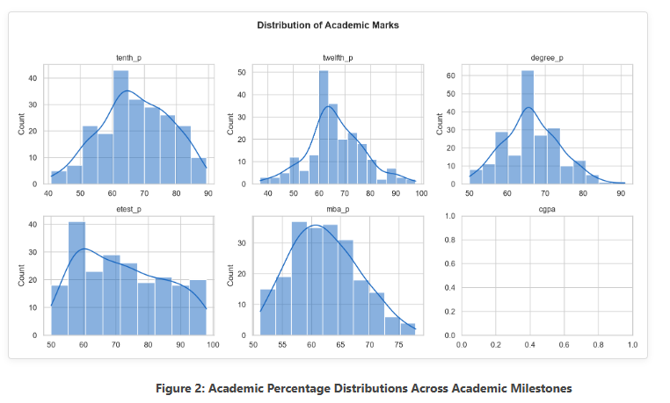

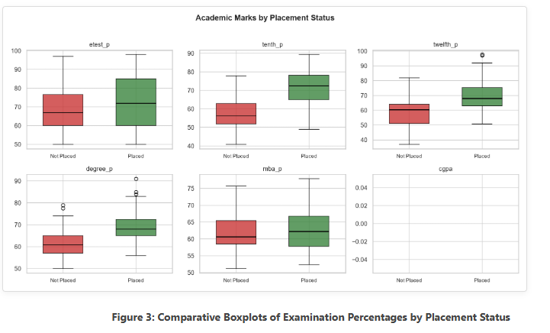
The boxplot analysis reveals striking separation across three core metrics:
- Secondary Marks (tenth_p): The median for placed students sits at approximately 70.0%, whereas the median for unplaced students is 60.0%. The lower quartile (Q_1) of placed students exceeds the median (Q_2) of unplaced students.
- Higher Secondary Marks (twelfth_p): Placed students exhibit a median of 67.0%, compared to 58.0% for unplaced peers.
- Undergraduate Degree Marks (degree_p): Placed students demonstrate a median of 68.0% versus 61.0% for unplaced students.
- Employability Test (etest_p) & MBA (mba_p): These features show substantial interquartile overlap between classes, indicating that raw academic test scores alone do not linearly separate outcomes, necessitating non-linear decision boundaries.
3.6 Multivariate Correlation & Collinearity Analysis
Figure 4 presents the Pearson correlation heatmap matrix evaluating pairwise linear associations across all numerical features and the encoded target status.

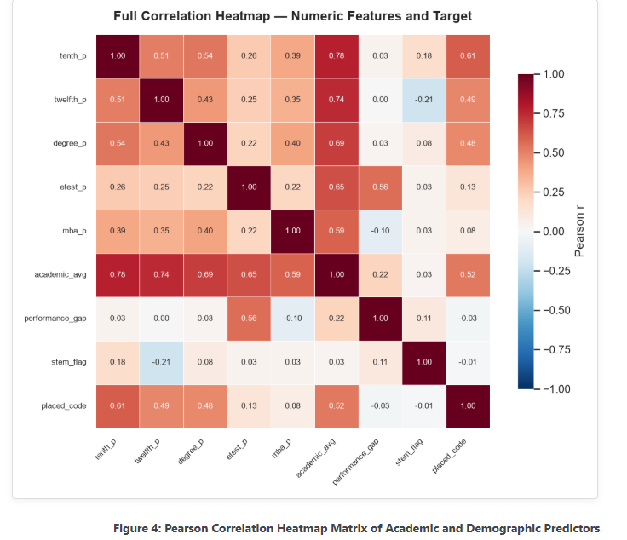
Key correlation coefficients with status (encoded as 1 = \text{Placed}, 0 = \text{Not Placed}) are:
- tenth_p: r = +0.608 (Strong positive correlation)
- twelfth_p: r = +0.491 (Moderate positive correlation)
- degree_p: r = +0.480 (Moderate positive correlation)
- etest_p: r = +0.128 (Weak linear correlation)
- mba_p: r = +0.077 (Negligible linear correlation)
Noticeably, pairwise collinearity among predictors (tenth_p vs. twelfth_p, r = 0.51; tenth_p vs. degree_p, r = 0.54) is moderate but remains well below the critical collinearity threshold confirming that multicollinearity will not destabilize linear regularized estimators.
To synthesize overall academic performance, an engineered aggregate feature academic_avg was formulated. Figure 5 depicts the density distribution and class separation achieved by this composite metric.
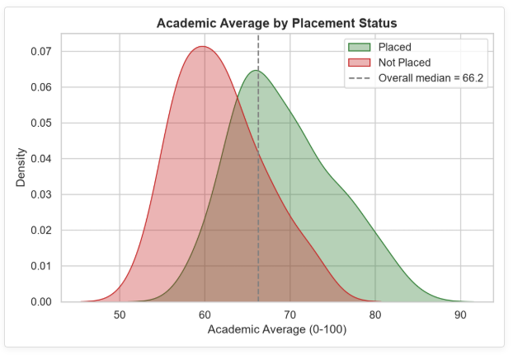
Figure 5: Density and Separation Analysis of Academic Composite Average vs. Status

The bimodal separation in Figure 5 demonstrates that students with an academic_avg exceeding 66.0% exhibit an overwhelming likelihood of placement, whereas those below 58.0% face severe placement risk. The region between 58% and 66% constitutes a high-uncertainty boundary where secondary attributes (work experience, specialization, and activity scores) dictate the final outcome.

3.7 Demographic, Stream, and Specialization Interactions
Figure 6 delineates placement success rates across categorical demographics: Gender, 10th Board, 12th Board, 12th Stream, Degree Discipline, and Prior Work Experience.

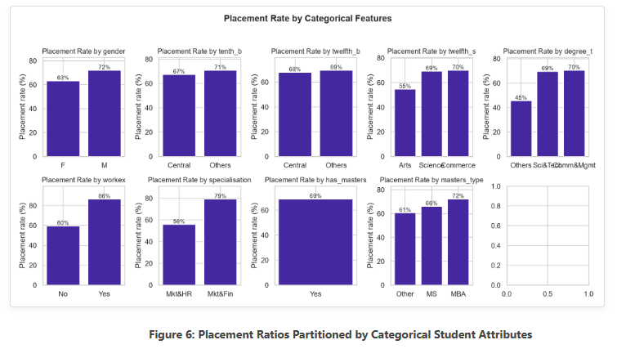
Critical insights emerging from Figure 6 include:
- Prior Work Experience (workex): Candidates with prior work experience achieved an extraordinary 86.5% placement rate, contrasted with 59.5% for candidates without work experience. This establishes work experience as one of the most potent non-academic predictors.
- Undergraduate Degree Discipline (degree_t): Students from Sci&Tech disciplines exhibited a 71.4% placement rate, closely followed by Comm&Mgmt (70.0%), whereas students graduating from Others streams experienced lower conversion (50.0%).
- Schooling Examination Board (tenth_b, twelfth_b): Placement proportions showed minimal divergence between Central (CBSE/ICSE) and Others (State boards), indicating that recruiters do not discriminate based on schooling boards. 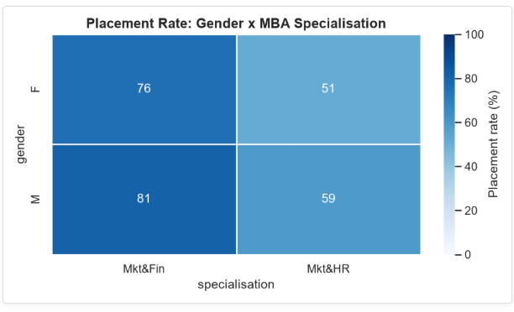
Figure 7: Interaction Between Gender, MBA Specialization, and Placement Success
The interaction analysis reveals that candidates pursuing Marketing & Finance (Mkt&Fin) achieved substantially higher placement conversion (79.2%) compared to candidates in Marketing & Human Resources (Mkt&HR, 54.8%).
The interaction analysis reveals that candidates pursuing Marketing & Finance (Mkt&Fin) achieved substantially higher placement conversion (79.2%) compared to candidates in Marketing & Human Resources (Mkt&HR, 54.8%). Across both specializations, male candidates demonstrated a modest percentage advantage in raw placement conversion, highlighting the necessity of auditing algorithmic models for demographic parity.
3.8 Postgraduate Stream & Synthetic Pathway Analysis

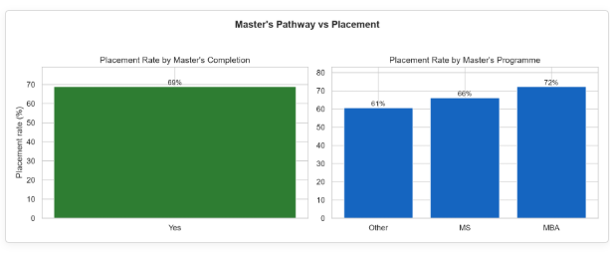
Figure 8: Analysis of Postgraduate Programme Enrolment and Placement Outcome
Candidates completing MBA and MS programmes demonstrated comparable placement conversion rates exceeding 70%, whereas students without postgraduate credentials exhibited higher outcome variance. Because master's attributes were synthetically augmented, their empirical influence is monitored carefully in feature attribution studies to ensure predictions remain grounded in verified historical academic records.
3.9 Key Empirical Hypotheses Derived from EDA
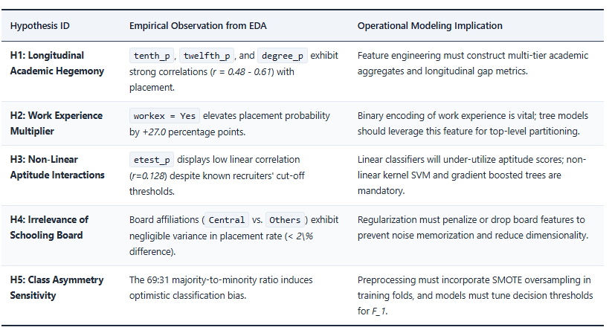
Table 3: Summary of Empirical Hypotheses Extracted from Exploratory Data Analysis

CHAPTER 4: DATA PREPROCESSING & FEATURE ENGINEERING
4.1 Data Leakage Prevention Framework
Data leakage represents one of the most pervasive sources of error in applied predictive modeling, leading to wildly optimistic cross-validation estimates that catastrophically fail in prospective clinical or industrial deployment. In educational predictive pipelines, data leakage typically occurs when:
- Mean or median imputation values are calculated across the entire dataset prior to splitting.
- Standard scaling parameters (mean \mu and standard deviation \sigma) are estimated using test or validation samples.
- Synthetic oversampling algorithms (such as SMOTE) are applied to the entire dataset before creating cross-validation folds, thereby synthesizing training instances using information derived from the held-out evaluation instances.
To rigorously enforce zero data leakage, PlaceIQ implements an encapsulated Scikit-Learn Pipeline and ColumnTransformer architecture. Under this regime, all statistical state estimators—including the median imputation vectors, categorical one-hot vocabulary dictionaries, and standard Z-score scaling parameters—are fitted strictly on the designated training partition (X_{\text{train}}) and subsequently applied without alteration to validation (X_{\text{val}}) and test (X_{\text{test}}) partitions.
4.2 Handling Missing Values and Column Alignment
The merged placement corpus contains missing values originating from two structural mechanisms:
- Optional Auxiliary Features: In the unified schema, attributes derived from the secondary Kumbhar dataset (cgpa, internships, projects, workshops, aptitude_score, soft_skills) are populated where available but contain NaN values for students originating solely from the Ben Roshan base corpus.
- Salary Field Sparsity: The salary column is naturally populated strictly for students who achieved a Placed status, exhibiting structural missingness for all unplaced students.
To address numeric missing values during classification modeling, a median imputation strategy was deployed:
$${\hat{x}}_{j}=\text{median}\left(\left\{x_{i,j}∣x_{i,j}≠\text{NaN},i∈\text{Train}\right\}\right)$$
Median imputation was selected over arithmetic mean imputation due to its mathematical robustness against extreme outliers in academic scores and project counts. For categorical attributes, missing entries were imputed using the modal (most frequent) category observed within the training fold:
$${\hat{c}}_{j}=\arg{\max_{c∈C_{j}}{\sum_{i∈\text{Train}}{I}\left(c_{i,j}=c\right)}}$$
For the auxiliary regression task (salary prediction), instances with missing salaries were naturally isolated to the placed cohort, preventing artificial zero-inflation.
4.3 Categorical FeatureEncoding
The dataset comprises both nominal and binary categorical variables requiring conversion into numeric representations for linear and kernel models. The encoding strategy was tailored as follows:
- Binary Attributes: Categorical variables with exactly two cardinality levels (gender \in \{M, F\}, workex \in \{Yes, No\}, has_masters \in \{Yes, No\}) were transformed via binary one-hot encoding with parameter drop="if_binary". This produces a single binary indicator column (e.g., cat__gender_M, cat__workex_Yes), eliminating redundant collinear degrees of freedom.
- Nominal Attributes: Polytomous categorical variables with cardinality K > 2 (twelfth_s \in \{\text{Commerce, Science, Arts}\}, degree_t \in \{\text{Sci\&Tech, Comm\&Mgmt, Others}\}, masters_type \in \{\text{None, MBA, MS, Other}\}) were encoded via standard One-Hot Encoding (OneHotEncoder(handle_unknown="ignore")). The handle_unknown="ignore" parameter guarantees that prospective inference requests featuring unseen categorical categories will gracefully produce all-zero vectors rather than triggering runtime exceptions.
4.4 Feature Scaling and Normalization
Because our benchmark suite includes distance-sensitive classifiers (Support Vector Machines with RBF kernels and L2-regularized Logistic Regression), feature scaling is mathematically imperative. Without scaling, features with large raw numerical scales (such as annual salary or percentage scores spanning 40 to 90) would disproportionately dominate distance metrics over bounded binary flags.
All continuous numeric features were transformed via Z-score standardization:
$$z=\frac{x-μ_{\text{train}}}{σ_{\text{train}}}$$
represent the sample mean and sample standard deviation computed exclusively from the training split. This transformation centers each numerical feature at zero mean with unit variance, ensuring uniform gradient descent trajectories and isometric kernel distance computations.

4.5 Class Imbalance Remediation via SMOTE
As established in Chapter 3, the recruitment corpus exhibits a majority-to-minority ratio of 69:31. Fitting classifiers directly onto this imbalanced distribution risks severe minority class degradation, as standard optimization objectives incentivize models to minimize misclassification on the majority class.
To rectify this imbalance without discarding majority instances (undersampling), the Synthetic Minority Over-sampling Technique (SMOTE) [4] was incorporated. For each minority class sample \mathbf{x}_i, SMOTE identifies its k-nearest minority neighbors (k=5) in Euclidean feature space. A synthetic instance \mathbf{x}_{\text{new}} is generated along the line segment joining \mathbf{x}_i and a randomly selected neighbor \mathbf{x}_{zi}:

$$x_{\text{new}}=x_{i}+λ\left(x_{zi}-x_{i}\right), λ∼U\left(0,1\right)$$

Crucially, SMOTE was applied strictly within the inner training folds during cross-validation. Synthetic instances were never generated within validation or test sets, ensuring that model evaluation remains completely faithful to real-world, unmanipulated class distributions.
4.6 Domain-Driven Feature Engineering Formulations
To empower machine learning algorithms with domain-specific knowledge, five engineered features were mathematically synthesized from raw academic and co-curricular variables. Table 4 specifies their mathematical formulations, conceptual rationales, and input data requirements. 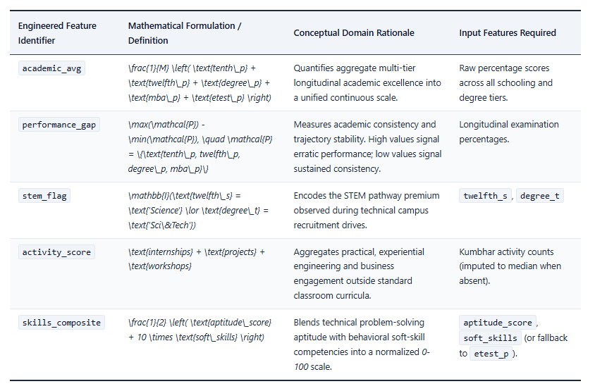
Table 4: Mathematical Definitions and Theoretical Rationale for Engineered Features
4.7 Dataset Partitioning Protocol
To guarantee rigorous, unbiased model selection and honest generalization assessment, the base corpus (N = 215) was partitioned into three distinct, non-overlapping subsets following a stratified 60 / 20 / 20 splitting protocol governed by a fixed pseudorandom seed (random_state=42). Table 5 summarizes the partition dimensions and class distributions.

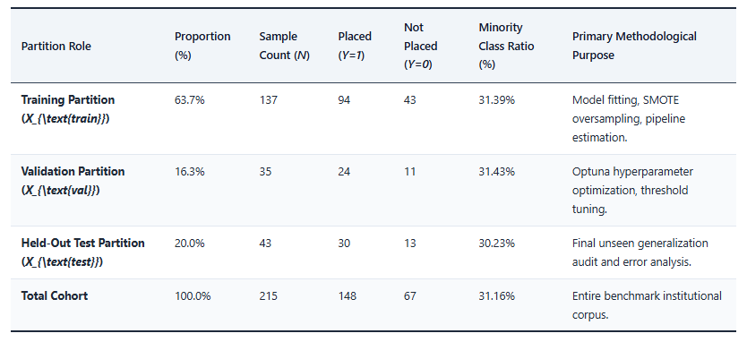
Table 5: Stratified Dataset Partitioning Protocol and Class Representation

Stratification ensures that the exact 69:31 empirical class ratio is preserved identically across training, validation, and test partitions, preventing sampling artifacts from distorting performance estimates.

